**ADDING SHAPEFILES FROM CITY OF KENNEWICK TO ARCGIS PRO**

1. Create a folder on your desktop where your downloads will be kept. Mine is called “Shapefiles”

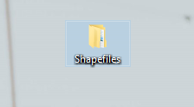

1. Follow the link:
   1. [SurveyParcel | SurveyParcel | City of Kennewick GIS Data (arcgis.com)](https://gisdata-kennewick.hub.arcgis.com/datasets/kennewick::surveyparcel/explore?location=46.196223%2C-119.161700%2C13.07)
2. On the left-hand side, click ***“Download”***

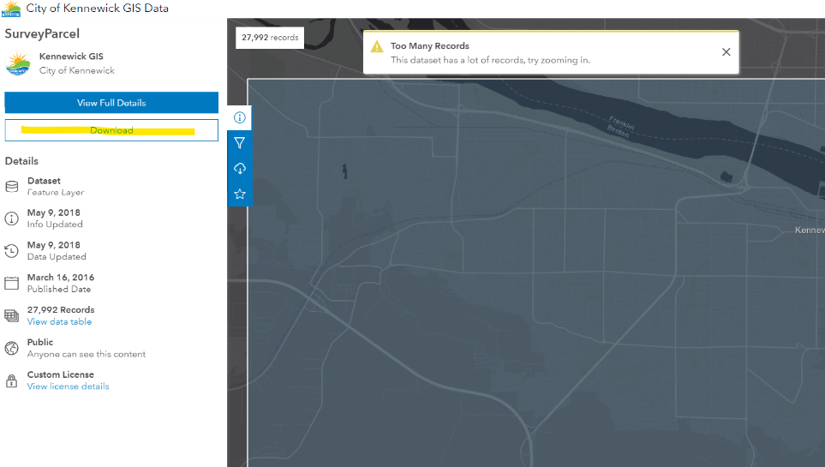

🡪

1. ***“Shapefile”*** will be one of the download options

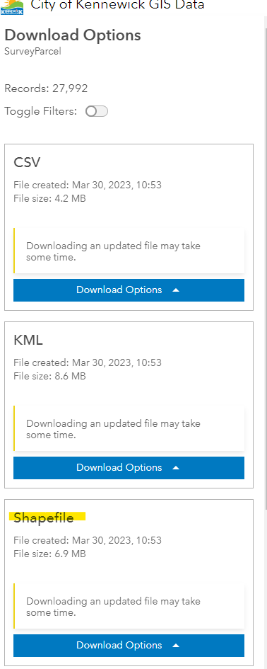

🡪

1. Expand the ***“Download Options”*** from Shapefile
2. Click ***“Generate new download with latest update”***

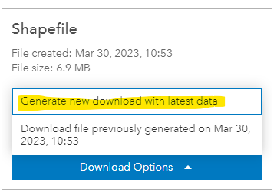

🡪

🡪

1. (It may take several minutes for the download to be completed)
2. Open the file once download is completed (Find the location where the file is downloaded)

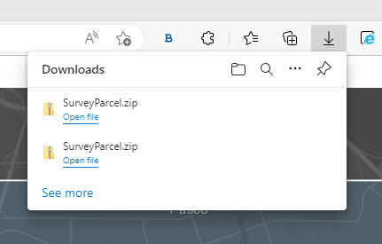

1. Move***.zip*** file from downloads to your saved desktop folder (Shapefiles)

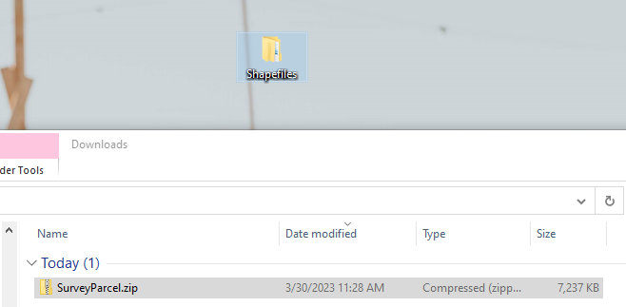

🡪

🡪

1. 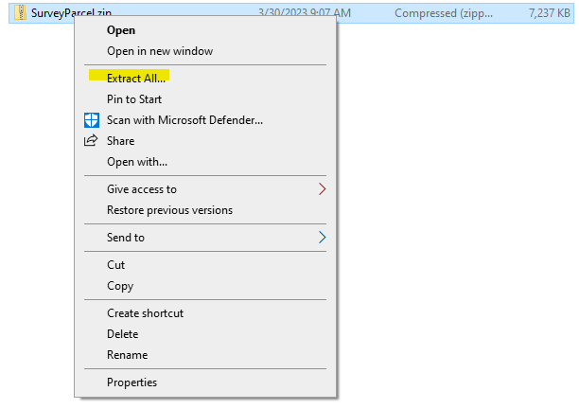Open Shapefiles **folder**, right-click on ***“SurveyParcel.zip”*** and click ***“Extract All…”***

🡪

**In ArcGIS Pro:**

1. Right click on folders and “Add ***folder connection”***

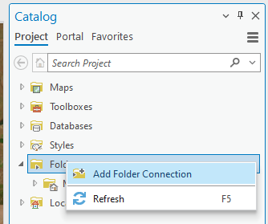

🡪

1. *Computer > This PC > Desktop*
2. Add ***“Shapefiles”*** folder

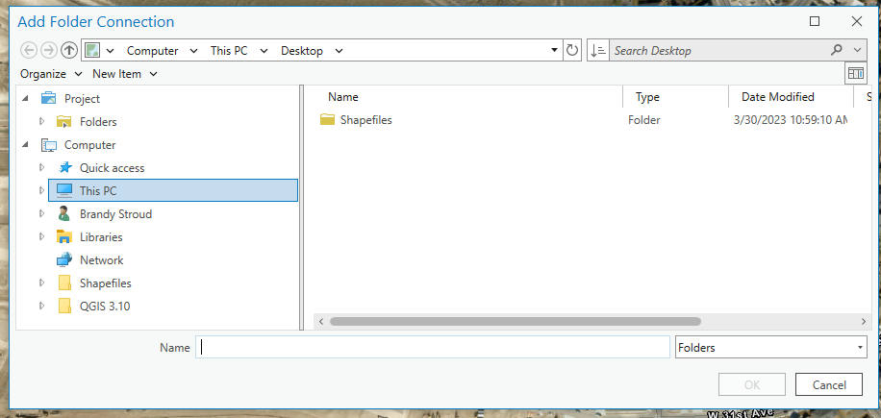

🡪

🡪

🡪

1. Add/drag folder to map



